**School of Technology, Pandit Deendayal Energy University, Gandhinagar**

**Course File (A to Z Essentials)**

|  |  |  |
| --- | --- | --- |
| **Name of the Course:** | | **Object Oriented Programming with Java** |
| **Course Code:** | | **23CP201T** |
| **Program:** | | **B. Tech.** |
| **Department:** | | **Computer Science Engineering** |
| **Semester:** | | **III** |
| **Academic Year:** | | **2023-24** |
| **Name of Course Coordinator:** | | **Dr. Debabrata Swain** |
| **Name of the Other Faculty Members** | | **Dr. Yogesh Kumar**  **Mrs. Nisha Chauhan** |
| **A** | **Course Syllabus, Prerequisites for the Course, Teaching Scheme, List of Books and Reference Books, etc.** | |
| **B** | **Lesson Plan (Hour-to-Hour Plan)** | |
| **C** | **Academic Calendar, Course Timetable, Faculty Timetable** | |
| **D** | **Course Outcomes (COs)** | |
| **E** | **Mapping of Course Outcomes with Programme Outcomes (POs)** | |
| **F** | **Evaluation Scheme and Rubrics** | |
| **G** | **Class Notes, Handouts, Course Material, etc.** | |
| **H** | **Course Presentations (PPTs) – If Applicable** | |
| **I** | **Tutorials, Assignments, Case Studies, Quiz, etc.** | |
| **J** | **Course-related ICT: Web links, Software, E-books, Relevant NPTEL and MOOC, Video Lectures, Blogs, Virtual labs, Animation, Simulation, etc.** | |
| **K** | **Laboratory Manuals – If Applicable** | |
| **L** | **List of International / National Journals related to the Course – If Applicable** | |
| **M** | **List of well-known Conferences related to the Course – If Applicable** | |
| **N** | **List of Classic Journal Papers / Articles / Review Papers related to the Course – If Applicable** | |
| **O** | **List of Renowned Industries / Organizations / working in the Course related areas** | |
| **P** | **List of Renowned Scientists / Academicians working in the Course related areas** | |
| **Q** | **Copies of the Mid and End Semester Examination Question Papers and Sample Answer Sheets** | |
| **R** | **Attendance Record** | |
| **S** | **Records of the Continuous Assessment (Assignment, Quiz, Laboratory Work, etc.)** | |
| **T** | **Details of Remedial Classes (with evidences)** | |
| **U** | **Details of Expert Lectures / Industrial Visits/Events (Only related to the Course)** | |
| **V** | **List of Slow and Advanced Learners, activity planned and executed** | |
| **W** | **Direct Assessment (Result of mid, end and internal assessment components)** | |
| **X** | **Indirect Assessment (Exit Survey/Post Test)** | |
| **Y** | **Final Attainment of COs and POs and Interpretation** | |
| **Z** | **Actions to be taken if COs and POs are not achieved** | |

**Date:**

|  |  |  |
| --- | --- | --- |
| **Signature of Subject Teachers** | **Signature of Department Coordinator (IQAC)** | **Signature of Head of the Department** |

1. **Course Syllabus, Prerequisites for the Course, Teaching Scheme, List of Books and Reference Books, etc.**

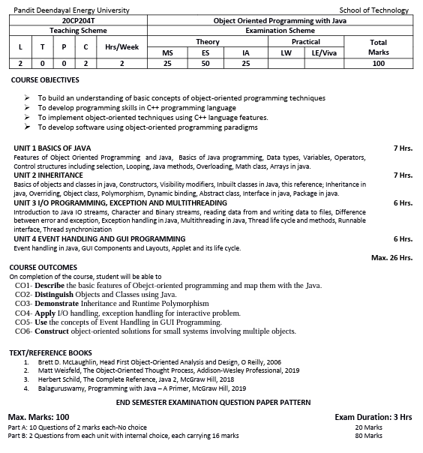

1. **Lesson Plan (Hour-to-Hour Plan) (Div 5)**

|  |  |  |  |  |  |
| --- | --- | --- | --- | --- | --- |
| **Lecture No.** | **Topic to be covered** | **Planned Date** | **Actual Conduction Date** | **Unit no** | **Method** |
| 1 | Features of Object Oriented Programming and Java |  |  | I |  |
| 2 | Features of Object Oriented Programming and Java |  |  | I |  |
| 3 | Basics of Java programming, Data types, Variables, Operators |  |  | I |  |
| 4 | Control structures including selection |  |  | I |  |
| 5 | Looping |  |  | I |  |
| 6 | Looping |  |  | I |  |
| 7 | Java methods |  |  | I |  |
| 8 | Overloading, Math class |  |  | I |  |
| 9 | Arrays in java |  |  | I |  |
| 10 | Arrays in java |  |  | I |  |
| 11 | Basics of objects and classes in java |  |  | II |  |
| 12 | Constructors, Visibility modifiers, Inbuilt classes in Java, this reference |  |  | II |  |
| 13 | Constructors, Visibility modifiers, Inbuilt classes in Java, this reference |  |  | II |  |
| 14 | Inheritance in java, Overriding, Object class |  |  | II |  |
| 15 | Inheritance in java, Overriding, Object class |  |  | II |  |
| 16 | Polymorphism, Dynamic binding, Abstract class |  |  | II |  |
| 17 | Polymorphism, Dynamic binding, Abstract class |  |  | II |  |
| 18 | Abstract class |  |  | II |  |
| 19 | Interface in java |  |  | II |  |
| 20 | Package in java |  |  | II |  |
| 21 | Introduction to Java IO streams, Character and Binary streams |  |  | III |  |
| 22 | Character and Binary streams |  |  | III |  |
| 23 | reading data from and writing data to files |  |  | III |  |
| 24 | reading data from and writing data to files |  |  | III |  |
| 25 | Difference between error and exception, Exception handling in Java |  |  | III |  |
| 26 | Exception handling in Java |  |  | III |  |
| 27 | Multithreading in Java, Thread life cycle |  |  | III |  |
| 28 | Thread life cycle and methods, Runnable interface |  |  | III |  |
| 29 | Thread life cycle and methods, Runnable interface |  |  | III |  |
| 30 | Thread synchronization |  |  | III |  |
| 31 | Thread synchronization |  |  | III |  |
| 32 | Event handling in Java |  |  | IV |  |
| 33 | Event handling in Java |  |  | IV |  |
| 34 | Event handling in Java |  |  | IV |  |
| 35 | GUI Components and Layouts |  |  | IV |  |
| 36 | GUI Components and Layouts |  |  | IV |  |
| 37 | GUI Components and Layouts |  |  | IV |  |
| 38 | GUI Components and Layouts |  |  | IV |  |
| 39 | GUI Components and Layouts |  |  | IV |  |
| 40 | Applet and its life cycle |  |  | IV |  |
| 41 | Applet and its life cycle |  |  | IV |  |
| 42 | Applet and its life cycle |  |  | IV |  |

**Lesson Plan (Hour-to-Hour Plan) (Div 6)**

|  |  |  |  |  |  |
| --- | --- | --- | --- | --- | --- |
| **Lecture No.** | **Topic to be covered** | **Planned Date** | **Actual Conduction Date** | **Unit no** | **Method** |
| 1 | Features of Object Oriented Programming and Java |  |  | I |  |
| 2 | Features of Object Oriented Programming and Java |  |  | I |  |
| 3 | Basics of Java programming, Data types, Variables, Operators |  |  | I |  |
| 4 | Control structures including selection |  |  | I |  |
| 5 | Looping |  |  | I |  |
| 6 | Looping |  |  | I |  |
| 7 | Java methods |  |  | I |  |
| 8 | Overloading, Math class |  |  | I |  |
| 9 | Arrays in java |  |  | I |  |
| 10 | Arrays in java |  |  | I |  |
| 11 | Basics of objects and classes in java |  |  | II |  |
| 12 | Constructors, Visibility modifiers, Inbuilt classes in Java, this reference |  |  | II |  |
| 13 | Constructors, Visibility modifiers, Inbuilt classes in Java, this reference |  |  | II |  |
| 14 | Inheritance in java, Overriding, Object class |  |  | II |  |
| 15 | Inheritance in java, Overriding, Object class |  |  | II |  |
| 16 | Polymorphism, Dynamic binding, Abstract class |  |  | II |  |
| 17 | Polymorphism, Dynamic binding, Abstract class |  |  | II |  |
| 18 | Abstract class |  |  | II |  |
| 19 | Interface in java |  |  | II |  |
| 20 | Package in java |  |  | II |  |
| 21 | Introduction to Java IO streams, Character and Binary streams |  |  | III |  |
| 22 | Character and Binary streams |  |  | III |  |
| 23 | reading data from and writing data to files |  |  | III |  |
| 24 | reading data from and writing data to files |  |  | III |  |
| 25 | Difference between error and exception, Exception handling in Java |  |  | III |  |
| 26 | Exception handling in Java |  |  | III |  |
| 27 | Multithreading in Java, Thread life cycle |  |  | III |  |
| 28 | Thread life cycle and methods, Runnable interface |  |  | III |  |
| 29 | Thread life cycle and methods, Runnable interface |  |  | III |  |
| 30 | Thread synchronization |  |  | III |  |
| 31 | Thread synchronization |  |  | III |  |
| 32 | Event handling in Java |  |  | IV |  |
| 33 | Event handling in Java |  |  | IV |  |
| 34 | Event handling in Java |  |  | IV |  |
| 35 | GUI Components and Layouts |  |  | IV |  |
| 36 | GUI Components and Layouts |  |  | IV |  |
| 37 | GUI Components and Layouts |  |  | IV |  |
| 38 | GUI Components and Layouts |  |  | IV |  |
| 39 | GUI Components and Layouts |  |  | IV |  |
| 40 | Applet and its life cycle |  |  | IV |  |
| 41 | Applet and its life cycle |  |  | IV |  |
| 42 | Applet and its life cycle |  |  | IV |  |

1. **Academic Calendar, Course Timetable, Faculty Timetable**

**Academic Calendar**

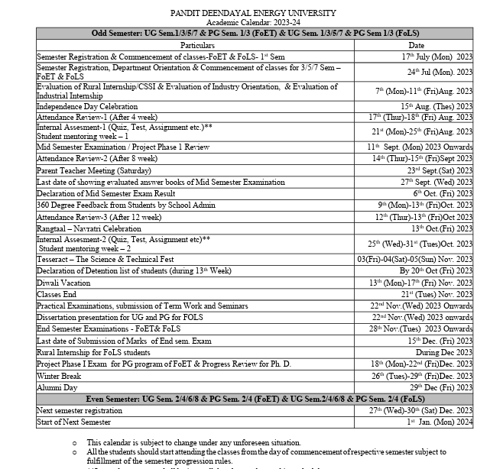

**Class Time Table – Semester 3 – Div 1**

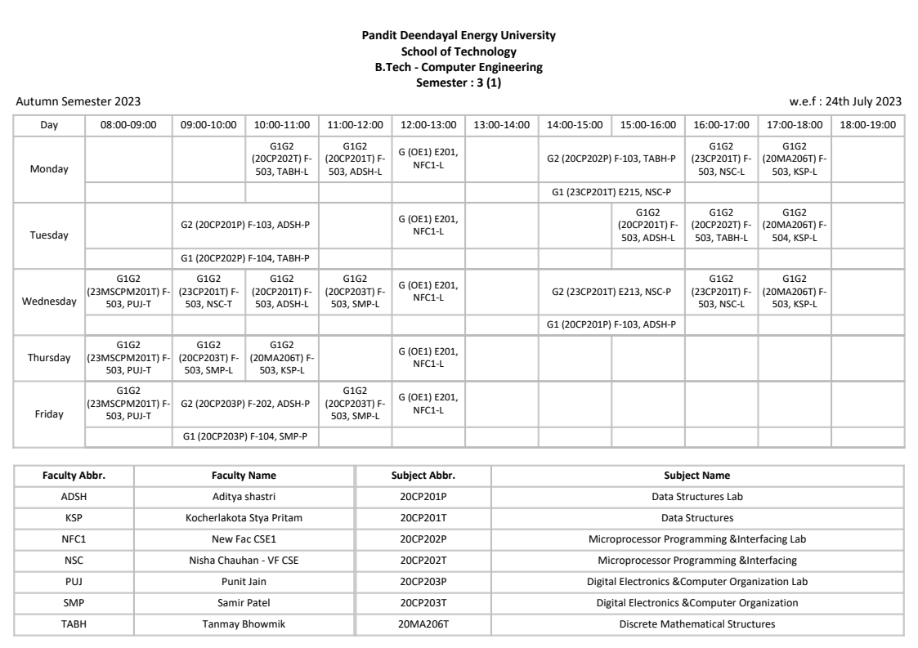

**Faculty Time Table**

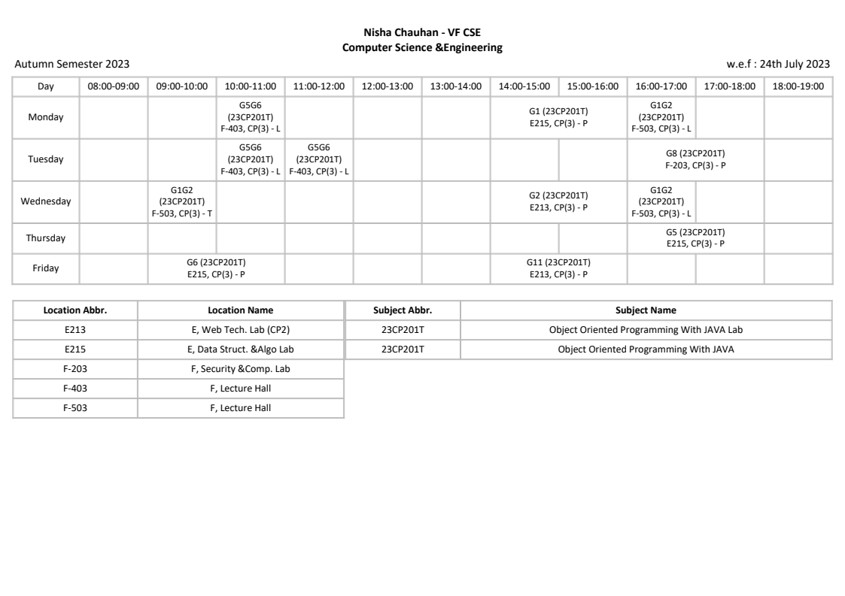

1. **Course Outcomes (COs)**

On Completion of the course, student will be able to

CO1- Describe the basic features of Obejct-oriented programming and map them with the Java.

CO2- Distinguish Objects and Classes using Java.

CO3- Demonstrate Inheritance and Runtime Polymorphism

CO4- Apply I/O handling, exception handling for interactive problem.

CO5- Use the concepts of Event Handling in GUI Programming.

CO6- Construct object-oriented solutions for small systems involving multiple objects.

1. **Mapping of Course Outcomes with Programme Outcomes (POs)**

**Course Articulation Matrix**

|  |  |  |  |  |  |  |  |  |  |  |  |  |  |  |  |
| --- | --- | --- | --- | --- | --- | --- | --- | --- | --- | --- | --- | --- | --- | --- | --- |
|  | **PO1** | **PO2** | **PO3** | **PO4** | **PO5** | **PO6** | **PO7** | **PO8** | **PO9** | **PO10** | **PO11** | **PO12** | **PS01** | **PSO2** | **PSO3** |
| **CO 1** | 1 | 3 | 3 | 3 | 2 | 1 | 1 | 1 | 1 | - | 2 | 1 | - | - | - |
| **CO 2** | 1 | 3 | 3 | 3 | 2 | 1 | 1 | 1 | 1 | - | 2 | 1 | - | - | - |
| **CO 3** | 1 | 3 | 3 | 3 | 2 | 1 | 1 | 1 | 1 | - | 2 | 1 | - | - | - |
| **CO 4** | 1 | 3 | 3 | 3 | 2 | 1 | 1 | 1 | 1 | - | 2 | 1 | - | - | - |
| **CO 5** | 1 | 3 | 3 | 3 | 2 | 1 | 1 | 1 | 1 | - | 2 | 1 | - | - | - |
| **CO 6** | 1 | 3 | 3 | 3 | 2 | 1 | 1 | 1 | 1 | - | 2 | 1 | - | - | - |

**Program Articulation Matrix**

|  |  |  |  |  |  |  |  |  |  |  |  |  |  |  |
| --- | --- | --- | --- | --- | --- | --- | --- | --- | --- | --- | --- | --- | --- | --- |
| **PO1** | **PO2** | **PO3** | **PO4** | **PO5** | **PO6** | **PO7** | **PO8** | **PO9** | **PO10** | **PO11** | **PO12** | **PS01** | **PSO2** | **PSO3** |
| 1 | 3 | 3 | 3 | 2 | 1 | 1 | 1 | 1 | - | 2 | 1 | - | - | - |

Correlation levels 1, 2 or 3 as defined below:

1: Slight (Low) 2: Moderate (Medium) 3: Substantial (High)

1. **Evaluation Scheme and Rubrics**

**CO Assessment Tools (Direct Assessment):**

Various assessment tools used to evaluate CO’s (Rubrics) and the frequency with which the assessment Processes are carried out are listed below.

|  |  |  |  |  |  |
| --- | --- | --- | --- | --- | --- |
| **Assessment Method** | **Assessment Tool** | **Description** | **Marks** | **Mapping with CO** | **Contribution to CO’s** |
| Direct | MID-Sem Examination | Topics to be covered till Unit - 2 | 50 | CO1,CO2, CO3 | It fractionally contributes to 25% weightage of Direct Assessment to CO attainment. |
|  | Total 50 marks will be converted into 25 marks for the mid-sem eval. | | | | |
| Direct | Assignments | For each unit a separate assignement will be prepared | 25 | CO1,CO2,  CO3 | It fractionally contributes to 25% weightage of Direct Assessment to CO attainment. |
|  | Total 25 marks will be converted into 25 marks for the continuous assessment. | | | | |
| Direct | End-Sem Examination | **Topics to be covered:** Unit I, II, III, IV | 100 | CO1,CO2,  CO3,CO4, CO5, CO6 | It contributes to 50% weightage of Direct Assessment to CO attainment. |
|  | Total 100 marks will be converted into 50 marks at the end. | | | | |

1. **Class Notes, Handouts, Course Material, etc.**

Uploaded in Teams Platform (One Sample PPT)

1. **Course Presentations (PPTs) – If Applicable**

Uploaded in Teams Platform

1. **Tutorials, Assignments, Case Studies, Quiz, etc.**
2. **Course-related ICT: Web links, Software, E-books, Relevant NPTEL and MOOC, Video Lectures, Blogs, Virtual labs, Animation, Simulation, etc.**

* https://www.youtube.com/watch?v=OjdT2l-EZJA&list=PLfn3cNtmZdPOe3R_wO_h540QNfMkCQ0ho
* https://www.youtube.com/watch?v=x1RCEvYRTz0&list=PL9ooVrP1hQOHb4bxoHauWVwNg4FweDItZ

1. **Laboratory Manuals – If Applicable**

NA

1. **List of International / National Journals related to the Course –**

* International Journal of Computer Applications Technology and Research
* International Research Journal of Engineering and Technology (IRJET)

1. **List of well-known Conferences related to the Course – NA**
2. **List of Classic Journal Papers / Articles / Review Papers related to the Course – NA**
3. **List of Renowned Industries / Organizations / working in the Course related areas**

* TCS, DA IICT Rd, Infocity, Gandhinagar
* Infosense, PDPU Road, Raysan, Gandhinagar
* IBM, GIFT city, Gandhinagar

1. **List of Renowned Scientists / Academicians working in the Course related areas**

Prof. Abhiram Ranade, IIT, Bombay

Mr. Navin Reddy, CEO, Telusko Learning

1. **Copies of the Mid and End Semester Examination Question Papers and Sample Answer Sheets-**
2. **Attendance Record- Available in TCS Ion**
3. **Records of the Continuous Assessment (Assignment, Quiz, Laboratory Work, etc.)**

Available in Teams Platform

1. **Details of Remedial Classes (with evidences)**
2. **Details of Expert Lectures / Industrial Visits/Events (Only related to the Course)**
3. **List of Slow and Advanced Learners, activity planned and executed**
4. **Direct Assessment (Result of mid, end and internal assessment components)**
5. **Indirect Assessment (Exit Survey/Post Test)**
6. **Final Attainment of COs and POs and Interpretation**
7. **Actions to be taken if COs and POs are not achieved**